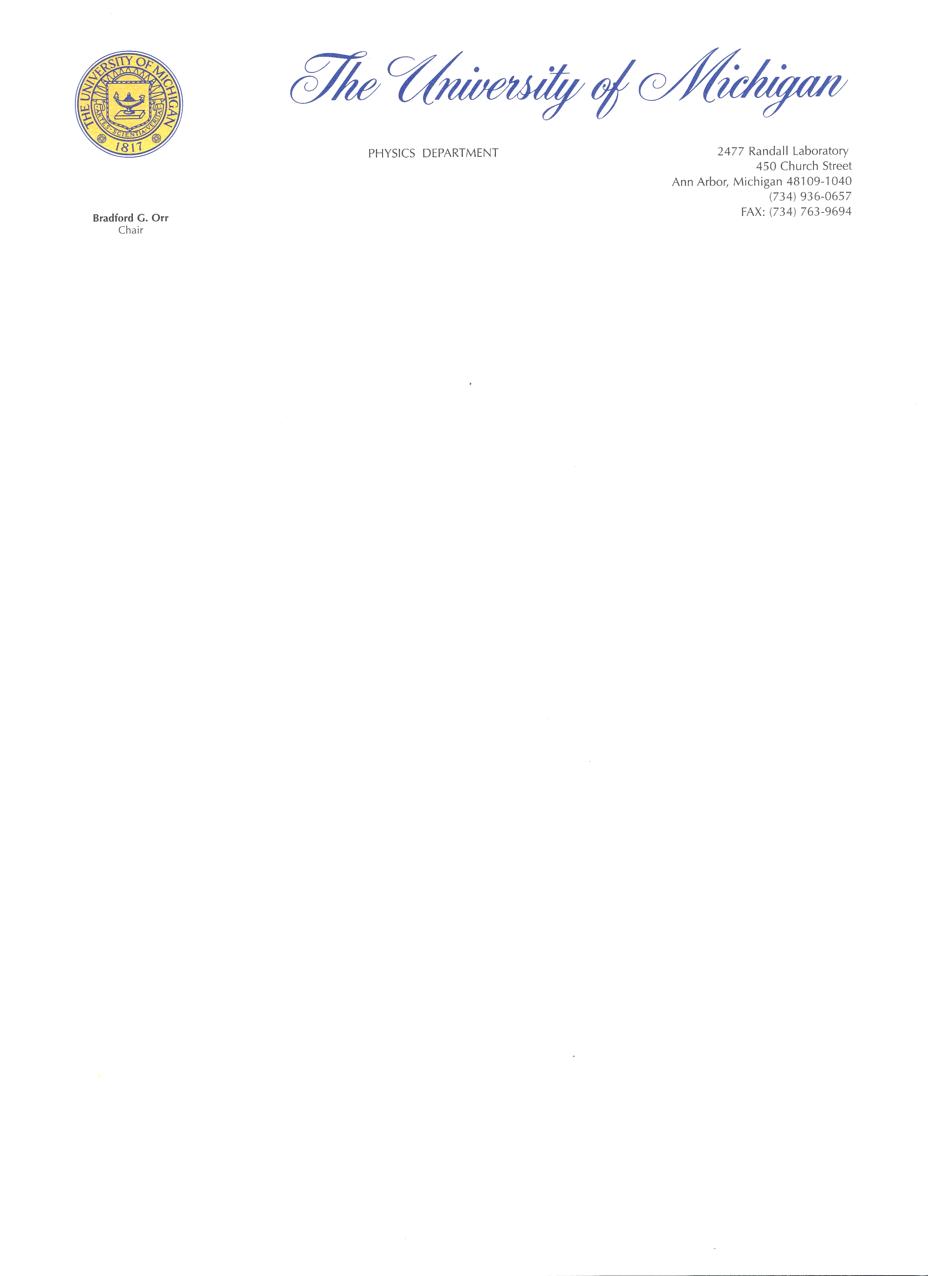

September 17, 2023

Dear Editors:

While this manuscript goes into the mathematical foundations of quantum mechanics, the core new idea is to look for physical justification of the mathematical structure, not simply internal mathematical consistency. We say this because in sharing drafts of the manuscript for feedback, the more mathematically inclined seemed to focus only on the mathematical part, missing the main point of the paper. Thus, we recommend not relying exclusively on reviewers who would focus primarily on the mathematical aspects of the manuscript. Ultimately, the conclusion can only be evaluated by someone who understands its physical significance.

Sincerely,



Christine A. Aidala  
 Professor of Physics  
 University of Michigan